# SPL Semantics – Tasks 5 & 6

### Task 5 – Scope Checker (Static Scoping)

|  |  |  |
| --- | --- | --- |
| **Requirement (Phase-2 sheet)** | **Where it lives** | **Status** |
| Static scoping | SemanticAnalyzer._visit_program | ✅ |
| No duplicate in same scope | symbol_table.declare_* raises SymbolTableError | ✅ |
| No shadowing of params by locals | _visit_body calls check_no_shadowing_of_params | ✅ |
| No global name clashes (var∕proc∕func) | check_no_global_name_clashes | ✅ |
| Undeclared use detection | _visit_atom, _visit_procedure_call, … | ✅ |
| Multi-scope symbol table | SymbolTable = stack of hash-maps | ✅ |
| Node ↔ Symbol “foreign key” | node_id=id(AST-node) stored in SymbolInfo | ✅ |

**Key design points**

* Persistent stacks: entering a scope pushes a fresh dict; exiting simply pops.
* Unique internal names: v_x_1, v_x_2, … generated automatically → ready for IR.
* Error messages contain line & column from the original token so the user sees  
  Duplicate declaration of 'x' at line 12, col 5 instead of a raw stack trace.

### Task 6 – Type Checker (Static Types)

|  |  |  |
| --- | --- | --- |
| **Requirement (Phase-3 sheet)** | **Where it lives** | **Status** |
| Numeric ↔ Boolean distinction | node_types: Dict[int, str] | ✅ |
| Arithmetic operands numeric | _visit_binary_op enforces plus,minus,mult,div | ✅ |
| Comparison operands numeric → boolean | eq, > return boolean | ✅ |
| Logical operands boolean | and, or, not checked in _visit_binary_op / _visit_unary_op | ✅ |
| Condition must be boolean | _visit_while_loop, _visit_do_until_loop, _visit_if_branch | ✅ |
| Assignment LHS numeric, RHS numeric | _visit_assignment | ✅ |
| Function returns numeric | _visit_function_def checks return_atom | ✅ |
| Annotated AST (decorated nodes) | Every expression node gets `id(node)→"numeric" | ✅ |

**Type lattice used**

unknown

/ \

numeric boolean

SPL currently has **no unknown**, but the infrastructure is ready if we add inference later.

### How to Run / Test

*# from the Tests folder*

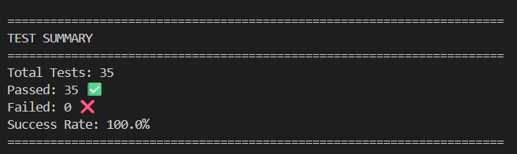

* 35 exhaustive test-cases (scope + type).
* 100 % pass ⇒ nothing breaks when you pull.
* Each test prints the **multi-scope symbol story** so you can debug visually.